Project Design Phase
Problem – Solution Fit Template

Date | 6 july 2026
Team ID
Project Name | Book store project
Maximum Marks | 2 Marks

Problem – Solution Fit Template:
The Problem-Solution Fit simply means that you have found a problem with your customer and that the solution you have realized for it actually solves the customer’s problem. It helps entrepreneurs, marketers and corporate innovators identify behavioral patterns and recognize what would work and why
Purpose:
- Solve complex problems in a way that fits the state of your customers.
- Succeed faster and increase your solution adoption by tapping into existing mediums and channels of behavior.
- Sharpen your communication and marketing strategy with the right triggers and messaging.
- Increase touch-points with your company by finding the right problem-behavior fit and building trust by solving frequent annoyances, or urgent or costly problems.
- Understand the existing situation in order to improve it for your target group.

Template:
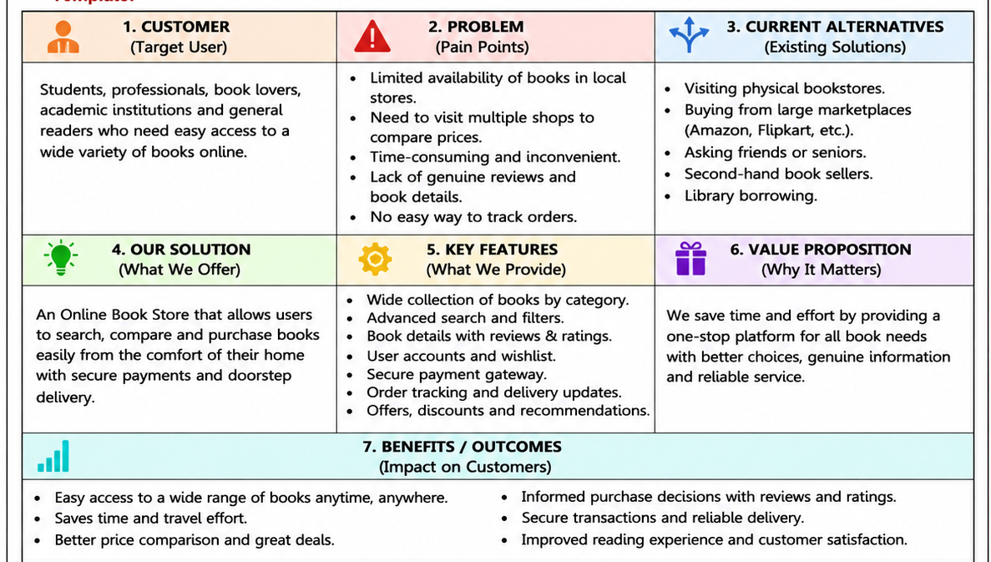
References:
- https://www.ideahackers.network/problem-solution-fit-canvas/
- https://medium.com/@epicantus/problem-solution-fit-canvas-aa3dd59cb4fe

Filled Problem–Solution Fit Canvas – Online Book Store Management System
Target Customers
Students, teachers, professionals, avid readers, and book store administrators.
Customer Problems
Books are hard to find locally; price comparison takes time; manual ordering is slow; limited stock visibility.
Current Solutions
Physical bookstores, multiple e-commerce sites, social media sellers.
Proposed Solution
A web-based online bookstore with searchable catalog, categories, secure login, cart, online payments, wishlist, and order tracking.
Unique Value Proposition
Buy books anytime, compare prices, receive recommendations, and enjoy doorstep delivery.
Key Features
Book search, filters, recommendations, cart, payment gateway, order history, admin inventory, user reviews.
Benefits
Saves time, improves accessibility, secure transactions, easy inventory management, better customer experience.

